Classical Regression Output

Coefficients: (1 not defined because of singularities)

Estimate Std. Error t value Pr(>|t|)

(Intercept) -7.5055 3.9087 -1.920 0.07177 .

xeaves 1.8981 0.9868 1.923 0.07133 .

xwindows 3.5310 1.6703 2.114 0.04960 *

xyard 2.5450 0.8721 2.918 0.00958 **

xroof NA NA NA NA

---

Signif. codes: 0 ‘***’ 0.001 ‘**’ 0.01 ‘*’ 0.05 ‘.’ 0.1 ‘ ’ 1

Residual standard error: 3.275 on 17 degrees of freedom

Multiple R-squared: 0.6318, Adjusted R-squared: 0.5668

F-statistic: 9.722 on 3 and 17 DF, p-value: 0.0005765

JAGS Output, unedited.

Inference for Bugs model in "housingmodel.txt", fit using jags,

5 chains, each with 5100 iterations (first 100 discarded)

n.sims = 25000 iterations saved

mu.vect sd.vect 2.5% 25% 50% 75% 97.5% Rhat n.eff

beta[1] 1.803 1.367 -0.876 0.890 1.799 2.721 4.479 1.001 7500

beta[2] 1.753 2.000 -2.198 0.392 1.752 3.110 5.663 1.001 13000

beta[3] 2.221 1.317 -0.344 1.342 2.217 3.113 4.807 1.001 18000

beta[4] 2.614 2.246 -1.742 1.089 2.592 4.117 7.060 1.001 25000

beta0 -6.982 3.824 -14.485 -9.569 -6.969 -4.385 0.389 1.001 25000

sigma 6.937 0.690 5.738 6.449 6.885 7.370 8.437 1.001 5600

tau 0.021 0.004 0.014 0.018 0.021 0.024 0.030 1.001 5600

Need to remember that the X’s are Eaves, Windows, Yards, Roof in that order. Much easier if we edit table above and stick names directly into the table.

|  |  |  |  |  |  |
| --- | --- | --- | --- | --- | --- |
|  | Node | mean | Sd | 2.50% | 97.50% |
| beta[1] | Eaves | 1.80 | 1.37 | -0.88 | 4.48 |
| beta[2] | Windows | 1.75 | 2.00 | -2.20 | 5.66 |
| beta[3] | Yard | 2.22 | 1.32 | -0.34 | 4.81 |
| beta[4] | Roof | 2.61 | 2.25 | -1.74 | 7.06 |
| beta0 | Intercept | -6.98 | 3.82 | -14.49 | 0.39 |
| sigma | Sd | 6.94 | 0.69 | 5.74 | 8.44 |
| tau | precision | 0.021 | 0.004 | 0.014 | 0.030 |

JAGS: 5 runs, 100 burnin each run, 5000 additional samples for 25,000 samples total.

Results from a previous run (in Winbugs). Note that some results differ slightly, usually in the .01 decimal location, occasionally in other places.

|  |  |  |  |  |  |
| --- | --- | --- | --- | --- | --- |
|  | Node | mean | sd | 2.50% | 97.50% |
| beta[1] | Eaves | 1.79 | 1.37 | -0.88 | 4.49 |
| beta[2] | Windows | 1.78 | 1.99 | -2.15 | 5.64 |
| beta[3] | Yard | 2.22 | 1.32 | -0.37 | 4.80 |
| beta[4] | Roof | 2.60 | 2.25 | -1.82 | 7.02 |
| beta0 | Intercept | -6.98 | 3.82 | -14.46 | 0.49 |
| sigma | sd | 6.94 | 0.69 | 5.75 | 8.44 |
| tau | precision | 0.021 | 0.004 | 0.014 | 0.030 |

Output has been appropriately massaged in excel.

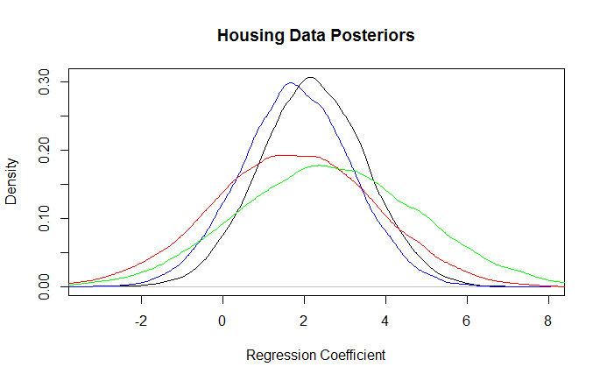

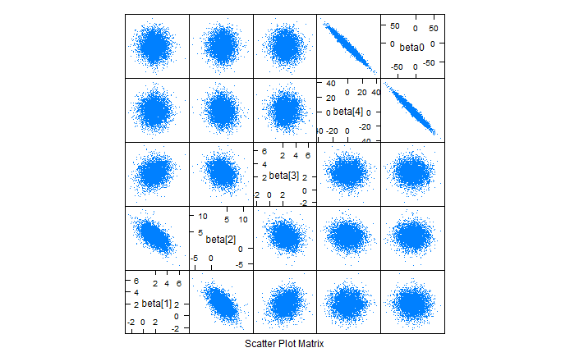

Scatterplot matrix for parameters using prior C.

Prior predictive distribution results

|  |
| --- |
| > print(lab2.simPP)  Inference for Bugs model at "housingmodel.txt", fit using jags,  5 chains, each with 5100 iterations (first 100 discarded)  n.sims = 25000 iterations saved  mu.vect sd.vect 2.5% 25% 50% 75% 97.5% Rhat n.eff  beta[1] 1.595 2.162 -2.631 0.137 1.595 3.049 5.860 1.001 25000  beta[2] 1.202 3.002 -4.625 -0.852 1.211 3.249 7.058 1.001 25000  beta[3] 2.347 2.188 -1.943 0.856 2.357 3.839 6.633 1.001 25000  beta[4] 3.640 2.722 -1.679 1.769 3.671 5.473 8.974 1.001 25000  beta0 -5.642 4.302 -14.000 -8.538 -5.653 -2.746 2.743 1.001 24000  sigma 8.323 1.053 6.557 7.581 8.224 8.950 10.677 1.001 25000  tau 0.015 0.004 0.009 0.012 0.015 0.017 0.023 1.001 25000  y[1] 13.469 14.683 -15.217 3.583 13.490 23.278 42.100 1.001 25000  y[2] 14.107 14.993 -15.068 3.980 14.161 24.150 43.559 1.001 25000  y[3] 14.507 15.480 -15.728 4.027 14.369 24.945 45.220 1.001 25000  y[4] 11.007 13.218 -14.718 2.053 11.067 19.944 36.890 1.001 25000  y[5] 19.780 17.676 -15.080 7.889 19.848 31.641 54.175 1.001 25000  y[6] 17.894 18.336 -18.007 5.454 17.919 30.214 53.928 1.001 25000  y[7] 16.797 17.556 -17.412 4.910 16.792 28.722 51.325 1.001 25000  y[8] 15.162 15.363 -14.644 4.709 15.176 25.519 45.163 1.001 25000  y[9] 10.449 13.082 -15.171 1.592 10.453 19.359 36.232 1.001 25000  y[10] 14.313 15.608 -16.242 3.807 14.326 24.905 45.070 1.001 25000  y[11] 15.099 16.794 -17.735 3.661 14.968 26.518 48.033 1.001 25000  y[12] 11.226 13.932 -15.834 1.729 11.087 20.613 38.563 1.001 25000  y[13] 18.937 17.592 -15.572 7.152 18.910 30.924 53.481 1.001 25000  y[14] 19.854 18.262 -15.970 7.549 19.829 32.061 55.706 1.001 25000  y[15] 14.654 16.212 -17.090 3.751 14.632 25.625 46.516 1.001 25000  y[16] 14.758 16.060 -16.716 4.000 14.699 25.566 46.326 1.001 25000  y[17] 15.165 16.480 -17.329 4.059 15.158 26.247 47.673 1.001 25000  y[18] 12.055 13.779 -14.684 2.771 12.032 21.374 38.878 1.001 25000  y[19] 12.548 14.162 -14.979 2.982 12.551 21.989 40.421 1.001 25000  y[20] 12.707 14.812 -16.429 2.698 12.845 22.773 41.612 1.001 25000  y[21] 13.065 15.408 -16.821 2.649 12.965 23.431 43.321 1.001 24000  For each parameter, n.eff is a crude measure of effective sample size,  and Rhat is the potential scale reduction factor (at convergence, Rhat=1). |

This output does not use the data y; it does use the covariate values. Results for the parameters should reproduce the prior exactly. The results for the y’s are prior predictive distributions, the distributions of y’s that we expect to see given the prior information only.